|  |  |
| --- | --- |
|  | Sagar Public School, Saket Nagar, Bhopal |

Certificate

**This is to certify that Mr./Ms. __________ Ojas Aklecha_____ Roll Number ______17__________of Class ______XI ‘B’________ has successfully completed his/her Practical work in Informatics Practices during the session 2019-20, strictly as per the guidelines of CBSE.**

**Date: ______05.02.2020____________**

**_____________________ _____________________**

**(Principal Signature) (Internal Signature)**

**____________________ ____________________**

**(Institution Stamp) (Examiner Signature)**

Acknowledgement

I express all my sincere thanks to my School Sagar Public, Saket Nagar, Bhopal for providing necessary facilities which were required for the completion of this Practical assignment.

I also acknowledge the support received from the IP teacher Mr. Vinod Kumar Singh, without their help, guidance, and support it could have been impossible to complete this assignment.

Lastly, I would thank the Principal of our School Ms. Pankaj Sharma for providing an opportunity to initiate ourselves with these kind of assignment.

**______Ojas Aklecha_____**

**Class : XI _’B’_**

INDEX

|  |  |  |
| --- | --- | --- |
| **S. N.** | **PARTICULAR’S** | **REMARK** |
| 1. | WAP in Python to calculate area of Triangle and Rectangle |  |
| 2. | Write a Menu Driven Program to perform Arithmetic operations. |  |
| 3. | WAP to input a number and check it is an even number or odd number. |  |
| 4. | WAP to find the greatest number out of three given numbers. |  |
| 5. | WAP to print Factorial of a given number. |  |
| 6. | WAP to print multiplication table of a number. |  |
| 7. | WAP to input a number and check it is prime or not. |  |
| 8. | WAP to generate Fibonacci series upto n terms. |  |
| 9. | WAP to input a number and display sum of its digits. |  |
| 10. | WAP to input a number and store its reverse in another variable. |  |
| 11. | WAP to input a string and check it is palindrome or not. |  |
| 12. | WAP to generate following pattern:  5 4 3 2 1 1 * * * * *  4 3 2 1 2 3 * * * *  3 2 1 4 5 6 * * *  2 1 7 8 9 10 * *  1 11 12 13 14 15 * |  |
| 13. | WAP to input a string and then prints a string that capitalizes every other letter in the string.  ( bhopal converts bHoPaL) |  |
| 14. | WAP to input a list find the minimum and maximum element in the list with its index value. |  |
| 15. | WAP to search for an element in a given list of numbers. |  |
| 16. | WAP to sort all elements of a list in ascending order. |  |
| 17. | Create a dictionary whose keys are month names and whose values are the number of days in the corresponding months.  a) Ask the user to enter a month name and use the dictionary to tell how many days are in the month.  b) Print out all of the keys in alphabetical order.  c) Print out all of the months with 31 days.  d) Print out the (key-value) pairs sorted by the number of days in each month. |  |
| 18. | WAP to sort (ascending and descending) a dictionary by its value. |  |
| 19. | WAP to demonstrate basic mathematical operations on numpy array. |  |
| 20. | WAP to create a 2D Numpy array and display:  a) sum of its all elements b) sum of all its row c) sum of all its column |  |
| 21. | MySQL commands |  |

1. WAP in Python to calculate area of Triangle and Rectangle.

**Ans –**

**Triangle -**

**a=float(input('Enter the breadth :'))**

**b=float(input('Enter the height :'))**

**c=(a*b)/2**

**print('Area of triangle',c)**

**Rectangle –**

**a=float(input('Enter the breadth :'))**

**b=float(input('Enter the height :'))**

**c=(a*b)*2**

**print('Area of rectangle',c)**

1. Write a Menu Driven Program to perform Arithmetic operations.

**Ans –**

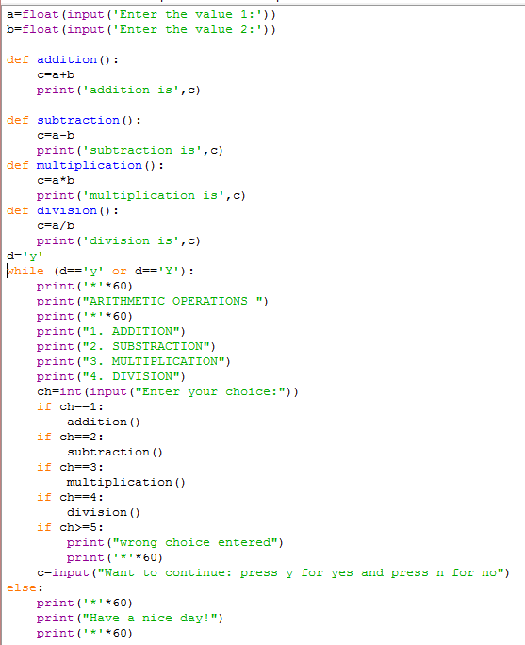

1. WAP to input a number and check it is an even number or odd number.

Ans –

**a=float(input('Enter the value 1:'))**

**if a%2==0:**

**print('It is even number')**

**else :**

**print('It is odd number')**

4. WAP to find the greatest number out of three given numbers.

Ans –

num1 = float(input("Enter first number: "))

num2 = float(input("Enter second number: "))

num3 = float(input("Enter third number: "))

if (num1 >= num2) and (num1 >= num3):

largest = num1

elif (num2 >= num1) and (num2 >= num3):

largest = num2

else:

largest = num3

print("The largest number is", largest)

5. WAP to print Factorial of a given number.

Ans –

a=int(input('Enter the number'))

b=1

for i in range(1,a+1):

b=b*i

print(b)

6. WAP to print multiplication table of a number.

Ans –

a=int(input('Enter the value:'))

for i in range(0,11):

b=a*i

i=i+1

print(b)

7. WAP to input a number and check it is prime or not.

Ans –

s=0

i=2

n=int(input("enter n"))

while i<=n-1:

if (n%i==0):

s=s+1

break

i=i+1

if s==0:

print("no. is prime")

else:

print("no. is not prime")

8. WAP to print Factorial of a given number.

Ans –

nterms = int(input("How many terms? "))

n1, n2 = 0, 1

count = 0

if nterms <= 0:

print("Please enter a positive integer")

elif nterms == 1:

print("Fibonacci sequence upto",nterms,":")

print(n1)

else:

print("Fibonacci sequence:")

while count < nterms:

print(n1)

nth = n1 + n2

n1 = n2

n2 = nth

count += 1

9. WAP to input a number and display sum of its digits.

Ans –

n=int(input('Input any number :'))

s=0

while n>0:

b=n%10

s=s+b

n=n//10

print('sum of the digits is ',s)

10. WAP to input a number and store its reverse in another variable.

Ans –

n=int(input("Enter number: "))

rev=0

while(n>0):

dig=n%10

rev=rev*10+dig

n=n//10

print("Reverse of the number:",rev)

11. WAP to input a string and check it is palindrome or not.

Ans –

a=str(input("enter a word"))

l=len(a)

z=''

for i in range(l,0,-1):

z=z+a[i-1]

if z==a:

print("palindrom")

else:

print("not palindrom")

12. WAP to generate pattern.

Ans –

Pattern 1 –

def contnum(n):

num = 1

for i in range(0, n):

for j in range(0, i+1):

print(num, end=" ")

num = num + 1

print(“\r”)

n=5

contnum(n)

Pattern 2 –

for i in range(1,6):

for j in range(1,i+1):

print('*',end='')

print()

Pattern 3 –

for i in range(6,1,-1):

for j in range(1,i):

print('*',end='')

print()

13. WAP to input a string and then prints a string that capitalizes every other letter in the string.

Ans –

14. WAP to input a list find the minimum and maximum element in the list with its index value.

Ans –

def minimum(a, n):

minpos = a.index(min(a))

maxpos = a.index(max(a))

print "The maximum is at position", maxpos + 1

     print "The minimum is at position", minpos + 1

a = [3, 4, 1, 3, 4, 5]

minimum(a, len(a))

15. WAP to search for an element in a given list of numbers.

Ans –

def search(arr, x):

     for i in range(len(arr)):

         if arr[i] == x:

             return i

     return -1

16. WAP to sort all elements of a list in ascending order.

Ans-

numbers = [1, 3, 4, 2]

   numbers.sort()

   print(numbers)